CHECK YOUR ANSWERS
Call me Ishmael. MOBY DICK

It is a truth universally acknowledged, that a single man in possession of a good fortune, must be in want of a wife. PRIDE AND PREJUDICE

It was a bright cold day in April, and the clocks were striking thirteen. 1984

It was the best of times, it was the worst of times, it was the age of wisdom, it was the age of foolishness, it was the epoch of belief, it was the epoch of incredulity, it was the season of Light, it was the season of Darkness, it was the spring of hope, it was the winter of despair. A TALE OF TWO CITIES
You don't know about me without you have read a book by the name of The Adventures of Tom Sawyer; but that ain't no matter. HUCKLEBERRY FINN
If you really want to hear about it, the first thing you'll probably want to know is where I was born, and what my lousy childhood was like, and how my parents were occupied and all before they had me, and all that David Copperfield kind of crap, but I don't feel like going into it, if you want to know the truth. THE CATCHER IN THE RYE
He was an old man who fished alone in a skiff in the Gulf Stream and he had gone eighty-four days now without taking a fish. THE OLD MAN AND THE SEA
It was a pleasure to burn. FAHRENHEIT 451
All children, except one, grow up. PETER PAN
In my younger and more vulnerable years my father gave me some advice that I've been turning over in my mind ever since. THE GREAT GATSBY
Late in the winter of my seventeenth year, my mother decided I was depressed, presumably because I rarely left the house, spent quite a lot of time in bed, read the same book over and over, ate infrequently, and devoted quite a bit of my abundant free time to thinking about death.
THE FAULT IN OUR STARS
If you are interested in stories with happy endings, you would be better off reading some other book. THE BAD BEGINNING
There is one mirror in my house.
DIVERGENT
Mr. and Mrs. Dursley of number four Privet Drive were proud to say that they were perfectly normal, thank you very much.
HARRY POTTER AND THE PHILOSOPHER’S STONE
When I wake up, the other side of the bed is cold. THE HUNGER GAMES
It’s a funny thing about mothers and fathers. Even when their own child is the most disgusting little blister you could ever imagine, they still think that he or she is wonderful.
MATILDA
Last night I dreamt I went to Manderley again.
REBECCA
The early summer sky was the color of cat vomit.
UGLIES
We should start back,” Gared urged as the woods began to grow dark around them.
A GAME OF THRONES
Alice was beginning to get very tired of sitting by her sister on the riverbank, and of having nothing to do: once or twice she had peeped into the book her sister was reading, but it had no pictures or conversations in it, 'and what is the use of a book', thought Alice, 'without pictures or conversation?'
ALICE IN WONDERLAND

TODAY

COME AND PLAY WITH BOOKS OPENING LINES
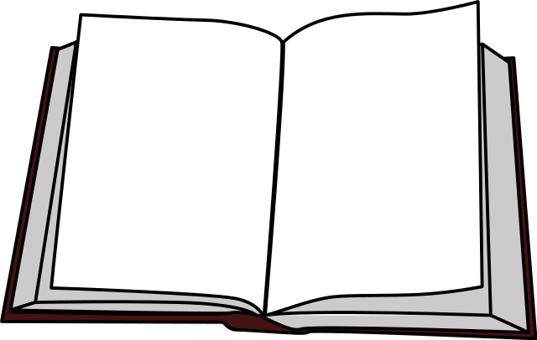
IN THE SCHOOL LIBRARY

